Einstein's Time

Toshio Suzuki∗

Abstract

This paper is to show a new thought on the time in the sense of theory of relativity of Albert Einstein (1879-1955). Actually, the speed of time varies in certain circumstances. For example, when two jetliners fly different courses, the clock on each plane shows different time. The reason for this phenomenon is explained in a way different from Einstein's theory of relativity.

I. Introduction

In the theory of relativity of Einstein, time mostly stops when an object moves at the speed close to the light. His theory has been verified in many instances. Here, three examples are mentioned. First example is “muon,” a particle that emerges from cosmic rays, second example is atomic clock in satellite of GPS (global positioning system), and third example is atomic clocks on two different points on Earth. With regard to the muon, the muon emerges when cosmic rays that came from outer space collides with the atmosphere of Earth. The life of this particle is very short. The average life is only two-millionths of a second. So it can travel about 660 meters even if it travels at the light speed. But it reaches the surface of Earth from the height of 10 and several thousand meters above the surface of Earth. It is thought that this phenomenon is due to the relativity of time. Namely, for observers on Earth, it looks like that the time delayed. Second example is atomic clock in satellite of GPS. GPS shows us our exact position on the Earth. So we can know the position of our car by this system. It uses four satellites in the space. So if the speed of time on Earth and the speed of time in the satellites are different, GPS cannot calculate the exact position. This really happens. Namely, atomic clock is installed on each satellite and this clock is very accurate when it is on Earth. But when the satellite is in orbit in space, atomic clock loses its accuracy. So time is corrected according to the theory of relativity of Einstein. First and second examples are found in encyclopedia and various websites on the Internet. Third example is written in a book of Wolfgang Rindler. He is a professor of physics at the University of Texas, USA. He writes:

Owing to this effect, the US atomic standard clocks kept since 1969 at the National Bureau of Standards at Boulder, Colorado, at an altitude of 5400 ft, as part of the International Atomic Time network, gain about five microseconds each year relative to similar clocks kept at the Royal Greenwich Observatory, England, at an altitude of only 80 ft. Since both sets of clocks are intrinsically accurate to one-tenth of microsecond per year, the effect is observable and is one of several that must be corrected for.

It is said that these examples support the theory of relativity. Object of this paper is to show a new thought on the theory of time.
Basic thought of this paper is written in a book Soul Federation. This paper was written to show only an essential part of the theory in a short paper.

II. ASSUMPTION

Energy Field

It is assumed that, in this world, an energy field exists. Needless to say, there are many energy fields such as magnetic field or field of gravitational force, etc. In this paper, the energy field means an energy field that is a mixture of magnetic field or field of gravitational force, etc. Namely the energy field in this paper is the existing field in the universe. It is assumed that the speed of movement of energy depends on the strength and property of this energy field. Because of this feature, time mostly stops when an object moves at the speed close to light.

III. ACTUAL PHENOMENA

1. Explanation Why the Time Delays When an Object Moves at the Speed Close to Light

Thus there are energy fields everywhere. Then, what kind of energy is it? It is the energy that involves gravity and other energies. The energy comes from matter in the Universe.
Energy has its own direction. Electric current has plus and minus. Magnetic force has plus and minus. Kinetic energy has direction. Thus energy has its own direction. So many energies neutralize each other. So, in the space, it is in the state of no gravity. This state is the state of Universe.
According to the theory of relativity, if an object moves at the light speed, time stops. Einstein explained this by thinking that time is relative. But I think as follows. Figure shows the relation between the movement of object and the movement of energy within the object in the energy field.

Figure. Energy field
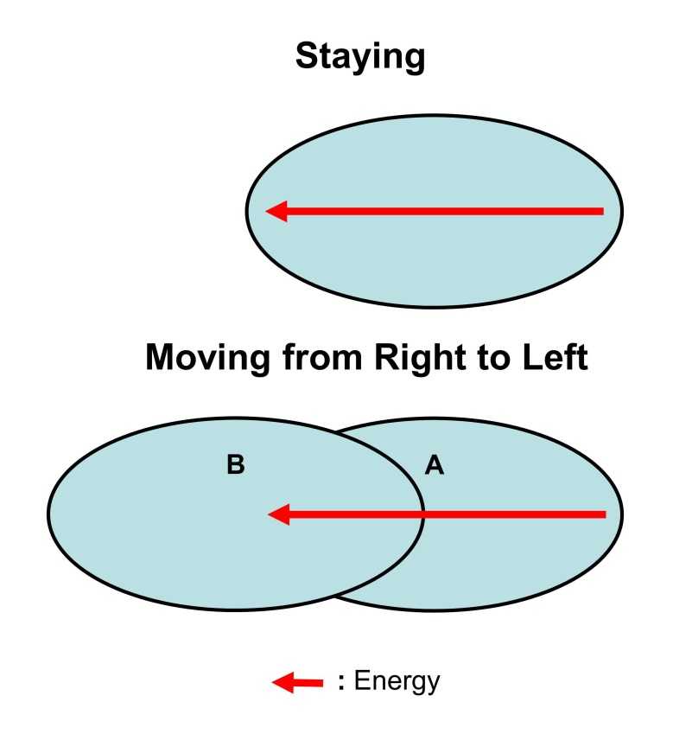
In the figure, ellipse means an object. Objects are in the energy field. The arrow shows the movement of energy. Some people say that the energy is a scalar quantity. But, actually energy such as light energy, thermal energy, etc. moves to certain direction. The energy starts to move from the right edge of the arrow. The arrow shows that the energy has moved from the right edge to the top point of arrow. We can think that matter reacts after the energy has moved within the matter. For example, a candle burns after the energy has moved in the candle. This can be said for everything. The speed of movement of energy is constant on the basis of the energy field. Or, the speed is constant as compared with the energy field. But, the energy field has no fixed point that can be a criterion of the position. So we should think that the criterion is our Galaxy. If we think that the Galaxy is a criterion, we can distinguish a moving object from a staying object. Thus we can know our position in the energy field by measuring our position in the Galaxy. In the figure, the upper object is staying at a point and the lower object is moving to the left at a speed close to the light. Namely, in case of the lower object, the object has moved from position A to position B. The arrow shows the movement of energy. In the upper object, the energy moved as shown in the figure. Namely, the energy moved from the right edge to the top of the arrow. So, in the upper object, the energy has moved from the right edge of the object to the left edge of the object. So, something has changed in the object. For example, if the upper object is a human, it has grown or got old to some extent. In case of the lower object, it is moving at a high speed close to the light. The energy in the lower object is moving at a speed same as the speed of the energy in the upper object. Namely, the speed of energy in the upper object and that of the lower object is same as compared with the energy field. But in case of lower object, it has moved at a speed close to the light. So the position of the energy in the lower object has not moved like the case of the upper object. Namely, the energy is around the center of the lower object. So, the reaction of matter was slow as compared with the upper object. If the object is human, she or he has not grown or has not got old like the case of the upper object. Thus, reaction or change of matter needs the movement of energy. Here, there is a question that if the movement of object is opposite to the above case, the reaction of matter will speed up. This point is not mentioned in this paper to simplify the explanation.

IV. Conclusion

Basically, conclusion of Einstein’s theory of relativity is correct. But the theory that explains the mechanism of phenomena is wrong. In the special theory of relativity, it is said that time is relative. In this theory, time delays when an object moves at high speed close to light. Actually, on two jetliners that fly different course, time shown by clock on the planes are different. It is said that this supports the theory of relativity. But, two jetliners fly different course and so the energy fields are different for each plane. This difference causes the difference of time shown on clock because the speed of movement of energy depends on the strength and property of energy field. Mystery of Bermuda Triangle can be explained by this thought. Namely, in the area of the Bermuda Triangle, the strength or the property of energy field was different. In case of life also, same thing can happen. If the speed of movement of energy is low, the life grows slowly or gets old slowly. In case of human also, the human grows or gets old slowly. According to Bible, Adam lived for 930 years and Noah lived for 950 years. Noah, who made ark, is one of Adam’s descendants. Also many Adam’s descendants lived for about 900 years. In Japan also, there is a similar example. According to Kojiki, some emperors lived over 120 years old and also other emperors lived close to it. This is not strange if their planet is in the energy field where the speed of movement of energy is much slower or if their planet was moving in the energy field at the speed much higher than the earth. Three examples mentioned earlier in this paper can be explained by this new thought.
Thus there is no time in a sense of Einstein's theory of relativity. But the speed of reaction of matter changes according to property or strength of energy field. Or, the speed of reaction of matter changes when an object is moving in an energy field at a very high speed. If we approach closer to the truth, we approach closer to the God.

References

In English

American Bible Society. Holy Bible. New Revised Standard Version. New York: American Bible Society, 1989.
Rindler, Wolfgang. Relativity: Special, General, and Cosmological. 2nd ed. New York: Oxford University Press Inc., 2006: reprint ed., New York: Oxford University Press Inc., 2007.
Suzuki Toshio. Soul Federation. Bloomington: Xlibris Corporation, 2010.
Wikipedia. “Theory of Relativity”. http://en.wikipedia.org/wiki/Theory_of_relativity: Wikipedia, 2007.

In Japanese

Oono, Yasumaro, and Arei, Hiedano. Kojiki. n.p.: n.p., 712.

∗ Toshio Suzuki, World Government Institute, 1-158 Nakakanasugi, Matsudo City, Chiba Prefecture, 270-0007, Japan.
Wolfgang Rindler, Relativity: Special, General, and Cosmological, 2nd ed. (New York: Oxford University Press Inc., 2006; reprint ed., New York: Oxford University Press Inc., 2007), 26.
Toshio Suzuki, Soul Federation, (Bloomington: Xlibris Corporation, 2010), 322-341.
For more detail, see page 338-341 in Toshio Suzuki, Soul Federation.
American Bible Society, Holy Bible, New Revised Standard Version (New York: American Bible Society, 1989), 4 and 8, Genesis, The Old Testament.
Yasumaro Oono and Arei Hiedano, Kojiki. (n.p.: n.p., 712).

