Maturing Soul

By

Toshio Suzuki

World Government Institute

© Copy Right, Toshio Suzuki, July 2022

All rights reserved. No part of this book may be reproduced or transmitted in any form or by any means, electronic or mechanical, including photocopying, recording, or by any information storage and retrieval system, without permission in writing from the copyright owner.

All rights reserved.

Toshio Suzuki
World Government Institute Japan
1-158 Nakakanasugi Matsudo City, Chiba Prefecture, 270-0007, Japan
Web Site: https://www.w-g.jp/

CONTENTS

CONTENTS iii
PREFACE 1
I. WHY DOES USA BOMB OTHER COUNTRIES? 3
II. WHAT IS SOUL? 5
1. Babic Components of Soul 5
2. Soul Is the Origin of Universe 8
3. Soul Outside of Life 9
4. Process of Reincarnation 9
III. PROGRESS OF MATURITY OF SOUL 11
IV. POWER OF SOUL 15
1. Soul can keep character, important memories, talent, religious mind, etc. even after reincarnation. 15
2. Soul can create life. 16
3. Soul can control the body of life. 16
4. Soul can make life evolve by affecting the arrangement of DNA. 16
5. Soul can affect the reincarnation of other souls. So, the reincarnation of each soul is affected by other souls. 16
V. HISTORY OF SOUL 19
1. Universes Other than Our Universe 19
2. Way of Living 20
3. Major Religions 21
4. Some Important Souls 22
VI. FUTURE OF SOUL 23
1. Directions of Evolution of Soul 23
2. How Should We Live? 26
3. India 27
4. China 27
5. USA 28
6. Japan 28
7. Roots of Each Nation on Other Planets 29
A. Roots of People in India 29
B. Roots of People in China 30
C. Roots of People in USA 30
D. Roots of People in Japan 30
8. In the Future 33
VII. WHAT SHOULD WE DO? 37
1. Policies Recommended 37
A. Division of Politics and Religion 37
B. Democratic Political Party 38
C. What Should USA Do? 40
D. An Idea of World Federation 40
E. Removal of Inappropriate Delegates 42
2. Finally 44

PREFACE

Title of essay “Maturing Soul” means that soul is maturing day by day. Basic topic of this essay is to consider the final goal of maturity of soul. In the process of maturity of soul, souls evolve to many directions. Some souls may grow or mature toward good souls smoothly. But some souls may grow to wrong direction. This essay is to analyze this. In other words, this essay is to write the property of soul that is maturing day by day.
In this essay, basic thought is that we must get old and die, and there are woman and man in this world, no matter how the science develops. So, if we want to be happy and enjoy life, we must build a healthy woman-man relation and have a healthy family. In other words, we must not have a sex without marriage. If we have a healthy woman-man relation and healthy family relation, we can be happy and enjoy life. I think if this way is followed, no country in the world will attack other countries without the approval of United Nations.
In other words, this is an essay to consider how we can be happy. When we consider how we can be happy, we must not forget that the most important factor is our own will. We or our soul have will. We cannot decide everything by our own will. But the decisive factor for our happiness is our own will. If we do good by our own will, property of our soul will improve though the improvement may be very slow.

I. WHY DOES USA BOMB OTHER COUNTRIES?

Here, we consider the attack to other countries without the approval of United Nations. Before the League of Nations and the United Nations were established, there was no international organization that can give approval to attack to other countries. So, in that era, wars were fought among some countries without the approval of international organization. The League of Nations was founded in 1920, and the United Nations was founded in 1945. After these organizations were founded, war among some countries were considered by these organizations. For example, Japan invaded China without the approval of international organizations around the period in 1920s. Japan invaded Manchuria in China and carried out Manchurian Incident in 1931 and constructed the State of Manchuria in 1932. China appealed to the League of Nations, and the League of Nations resolved that Japan should withdraw from Manchuria with 42 : 1 (1 is Japan). Japan withdraw from the League of Nations in 1933.
Thus, in the present age, international organizations can publish international opinion. But some countries attack other countries without the approval of international organization such as United Nations. Namely, each country attacks other countries for their own benefits. They do not think of benefits of world as a whole. For example, in 2001, Islamic activists attacked World Trade Center in New York and other facilities in USA. Fundamental cause of this attack was the attacks by USA to other countries without approval of United Nations. USA has been carrying out wars against other countries without the approval of United Nations. This is a tradition of USA. This tradition is based on the low maturity of soul of Americans. Then what is the basis of this tradition of USA? Here, we consider this tradition from a viewpoint of maturity of soul.
For example, in 2003, USA and allies invaded Iraq without the approval of United Nations insisting that Iraq has weapons of mass destruction. Attacks to other countries or invasion to other countries are due to the low maturity of soul. Basically, leaders of USA think that everything is OK if science develops, economy grows, and they can win war. This is the essence of history of USA. As a result, leaders of USA treat people in other countries as livestock.
It is said that all the Presidents of USA are, except one President, descendants of the King of England, John. Magna Carta was written in 1215 when he was the king. Barack Obama is a man of mixed blood and was the President of USA from 2009 to 2017. Even he is one of the King John’s descendants. As for Japan, traditional ruling people are those who worship the emperor. Emperor has been existing for more than 1 thousand years. From these things, we can think that soul is very important. Soul of ruling people have been inherited for thousands of years. So, their politics has been inherited. Basically, ruling people have ruled other people by defeating them by war. This tradition is still continuing. So, USA attacks other countries without the approval of United Nations. In USA, the politics is democracy. But, in the world, USA attacks other countries without respecting the United Nations. Needless to say, this is a tradition of USA. So, nobody is personally responsible for this. Tradition of people is responsible. Tradition of people is based on the soul of people. In this point, we must consider the maturity of soul. After considering the maturity of soul, we can think of direction of evolution or maturity of soul in the future. To which direction does soul mature or evolve? In other words, will our soul love peace or love war in the future? This is, in a sense, the topic of this essay.
Actually, in the present world, leaders of world are based on the military power of each country. For example, USA is the most powerful country in the world. Its power is based on the military power, not love for people. On the other hand, some people hope for the politics based the democracy. For example, Mahatma Gandhi is famous in the history. He led India to independence by the policy of non-violence. His power was based on the love for people.
In following part of this essay, we consider the actual situation of maturity of soul of people and consider whether we can eradicate the war or not by maturing our soul.

II. WHAT IS SOUL?

Basic topic of this essay is to consider how we can be happy and enjoy life. In a sense, this essay is to consider the maturity of soul. In other words, we are trying to consider the direction of evolution of souls. So, we must consider the basic property of soul. When soul is in a body of life, it can see, hear, and feel about the outer world. For example, when soul is in a human body, she or he can see, hear, and feel many things. But when soul is out of any life, she or he can feel something but cannot know outer world.
When we die, our soul gets out of body. But the soul is around us. The souls around us will be reincarnated into other lives such as bird, cat, dog, human, etc. Then, what is soul? Basically, soul is energy or mind itself. Fundamentally, soul is female or male. Basic element of soul is the Unit Soul that is plus energy or minus energy. In other words, Unit Soul is female soul or male soul. Unit souls is female or male, and so there are woman and man in this world. This does not change no matter how science develops. And also, we must get old and die no matter how science develops. These things show that we must build healthy woman-man relation and have a healthy family relation if we want to be happy and enjoy life.

1. Babic Components of Soul

These Unit Souls are combined together and become soul or energy or matter. It is shown in the Figure II-1. As shown in the figure, Each Unit soul is a single entity that is plus or minus. Combined Unit Souls become soul or matter or energy depending on the way of combination of Unit Souls. As shown in Figure II-2, soul, energy, and matter changes into another situation. In this point, there is an interesting report. There is a religious corporation "Happy Science". The number of members of this corporation is claimed to be around 11 million. Founder is Ryuho Okawa. He claims that powder of gold sometimes falls when he speaks to people. This powder vanishes within a week. He wrote that soul energy changed to this powder. This book was published in 2020 with the title The Laws of Steel. This is written in pages from 326 to 328. This may be a lie. But as far as I know, he does not write a lie in his book.
A change from matter to energy is shown by famous Einstein’s equation.

E = mc²

E: Energy
m: mass
c: speed of light.

Needless to say, the equation means that energy emerges from matter and this is a theoretical explanation of atomic bomb. The speed of light is constant. So, the amount of energy depends on the mass. If the mass reaches certain point, the nuclear fission occurs. This is the explosion of atomic bomb.

Figure II-1. Unit Soul and Its Combination

II-2. Transformation of Matter, Energy, and Soul

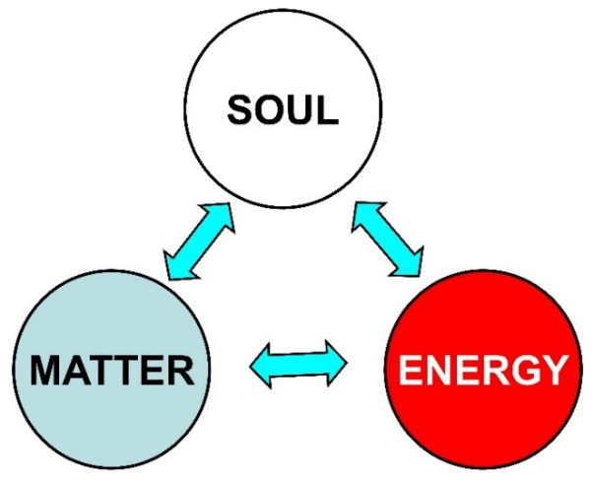

These Unit Souls combine in various ways and this combination decides the situation of soul, energy, and matter. It is shown in the Figure II-3 below. The figure shows that Unit Souls become soul, light, muon, water, etc. depending on combination of Unit Souls. Each Unit Soul has a desire to feel happy. Unit Soul combines together and become souls of worms, fish, birds, mammals, etc. Every soul wants to feel happy and enjoy life. When soul feels happy and enjoy life, situation of combination of Unit Soul is in a certain situation. So, soul tries to approach this situation. This trial is efforts. If soul makes efforts by its own will, situation of combination of Unit Souls changes and the situation becomes better. So, the soul can feel happier. In a bad situation of combination, the soul must feel unhappy. So, the soul tries to get out of the bad situation. Needless to say, we sometimes feel happy and pleasant, and sometimes feel unhappy and unpleasant. This depends on the situation of combination of Unit Souls. Then, why do we feel happy and unhappy? This feeling cannot be explained by science because mind of soul cannot be explained by science.

Figure II-3. Combination of Unit Soul

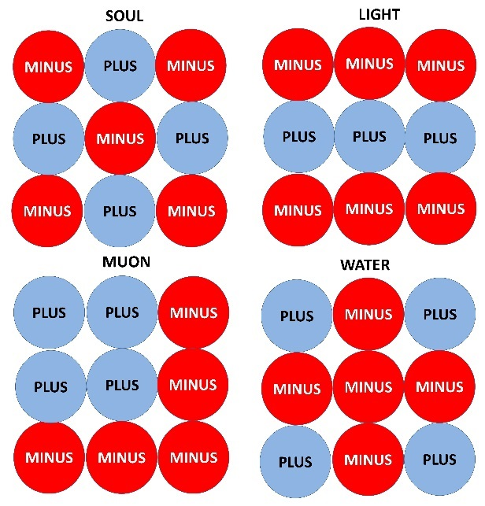

Needless to say, there are female souls and mail souls. What is the difference between the female soul and the male soul? Also, the difference between female body and male body is important. Chromosomes of female and male are different. So, some organs including the sexual organs are different. As for soul, characters of female soul and male soul are different. This is based on the basic structure of soul. Namely, soul is composed of Unit Souls. Unit Soul is plus soul or minus soul. This results in the fact that there are female and male soul in this world. Namely, depending on the combination of Unit Souls, soul becomes female soul or male soul. Basically, female soul is born into female body, and male soul is born into male body. Sometimes, female soul is born into a male body, and male soul is born into a female body. In this case, lesbian or homosexual is born. In a soul, when the proportion of female Unit Soul is higher than that of male Unit Soul, the soul is a female soul. When the proportion of male Unit Soul is higher than that of female Unit Soul, the soul is male soul. The process of maturity of soul will be considered later.
In a sense, the topic of this essay is to understand the process of maturity of soul and to forecast the final destination of matured soul. I think our soul will evolve or mature and common sense will be formed in every aspect of culture. For example, it is a common sense that harmful drag such as heroin or cocaine are forbidden among ordinary people. But, there is no common sense in the world with respect to woman-man relation. Generally, in industrialized country such as USA, Europe, Japan, etc., many people have sex without marriage. On the other hand, in Islamic countries and Hindu countries, sex without marriage is strictly forbidden. It seems that this is because the maturity of soul is different between two cultures. If our soul is matured to a certain extent, a common sense about the woman-man relation will be formed in the future. This will be considered later in this essay.

2. Soul Is the Origin of Universe

Let us think of the origin of universe. It is often said that the universe was created by the god. Still, there is no definite opinion about the origin of universe. I would like to express my opinion. The beginning of universe was the existence of Unit Souls. Before the Unit Soul appeared, the situation is not imaginable. But this thought is closer to the truth than any other thoughts on the origin of universe. Needless to say, in the future, we may have a thought that is closer to the truth than my present thought. But, anyway, le me write my thought.
At the very beginning, only Unit Souls existed in the space. There were no matter and no energy. But the Unit Souls have mind or instinct. That mind is the desire to be happy and enjoy. This is very simple but absolute. This mind is the power that made the universe and life. The Unite Soul has the property of gathering together. This property is the power of gravity. These Unit Souls form the field of energy. But the power of gravity cannot be explained scientifically. Also, this mind is the origin of the power that seeks the sex. First of all, this power made the matter in space. The matter can change into energy. So the matter and the energy made a universe. Unit Soul are existing in the space of universe. If two objects exist in the field of energy, they draw each other. This is the cause of gravity. When matter and energy appear in the world, soul emerges. This soul can make life. When life emerges, DNA is necessary. Arrangement of DNA must be specified by something. In this process, soul can specify the arrangement. In a soul, many Unit Souls gather. This is because each Unit Souls wants to gather together. This is the origin of power of gravity. This power is combined and can make stars and galaxy. Planet revolves around the sun due to the power of soul. Planet cannot maintain its orbit without the will of soul. This is the power of soul. Thus, Unit Souls are the god. In other words, they can play the role of god. In this sense, universe was made by god.
There are Unit Souls in the universe. Those Unit Souls want to enter body of life because they want to feel happy and enjoy. Especially, they cannot have sex when they are out of life.

3. Soul Outside of Life

Every life has a soul in its body. If the life dies, the soul must go out of the body of life. Then where is the soul out of body? Each soul gathers together. This gathering of souls forms a mass of souls. This is another world. This world cannot be seen. But this world exists around us. This is the Spirit World. In Buddhism, it is said that we repeat reincarnation and finally we emancipate ourselves from all worldly desires and worries. Namely, souls go to this Spirit World. But some souls return to our real world again. This is the reincarnation.

4. Process of Reincarnation

If a life dies, soul must go out of its body. When a soul is in a body of life, it can know the situation of the outer world. This is possible through eye, ear, hand, etc. Situation of the outer world is transferred by these organs. Then, what is brain? Many people think that brain is soul itself or brain thinks many things. I think that brain is a gathering of nerves that are corridors or routes of soul. Or, the nerve is circuit of signals among souls. Nerve is not the soul itself, and the nerve cannot think anything. The nerve helps the soul to move and combine with other souls or helps to exchange signal among souls. Soul can think many things by combining together or by exchanging information. For example, suppose there are two desires in a brain. One desire is to work earnestly and contribute to society. Another desire is to earn big money by committing a crime. In this case, which desire prevails in his mind? The former desire and the latter desire move through the nerve and combine or exchange signals mutually. Basically, stronger desire will decide his action. But there is another factor. It is his own will. He will hesitate to choose the way to go. After considering, he will decide. This will affect his character. If he decides to work earnestly, good soul will join to his soul, and so his character will become better. But, if he decides to earn money by committing crimes, bad soul will join to his soul and his character will become evil. Thus, the will of a person affects his life.
There is one important factor that allows each soul to be reincarnated. In the universe, souls out of life want to enter a life. When soul is reincarnated into a life, the soul must be allowed by other souls or cooperated by other souls. So, if a soul did good when she or he was in a life, other souls help it to enter healthy and strong life. For example, a soul that worked earnestly can be reincarnated into a healthy and beautiful person or a rich family. But, if a soul did bad things, she or he will be reincarnated into an ugly or handicapped person. Thus, reincarnation of a soul is affected by other souls. Namely, soul in the Spirit World are playing the role of God.
In the Spirit World, there are many souls that cannot enter the brain of life. Some soul cannot enter the brain because the property of soul does not match with the brain. Some souls cannot enter the brain because the size of soul is too big as compared with brain, though the property of brain is not the problem. They are too big so cannot enter the brain. Such big souls cannot enter even a human brain. If the soul shrinks into a smaller soul, the soul can enter the human brain. Or, if human brain evolves into a bigger brain, the brain can accept such a big soul. Brain of human may become like that in the future.
If a human body dies, the soul inside the body must go out of the body. Some souls enter a brain of human very soon, for example, in a week. Some souls must stay in the Spirit World for thousands of years. It is said that there is no lie among souls in the Spirit World. This is because souls are combined together in the Spirit World. When souls are reincarnated into body of a life, they separate from other souls and enter the body of life. Souls that cannot be reincarnated into life for a certain period of time become matter. Namely, they fall into the hell.
We are instinctively feeling about our life after death. If someone is destined to be reincarnated after ten thousand years or later, she or he will think that their life will be eternally finished after death. Such people feel that there is nothing after death. They may say, "I do not want to die". On the other hand, if someone is destined to be reincarnated after one week, she or he will feel that there is another life after death. Such people make a plan for next life. For example, they think they will become a scientist in next life, and in the life after the next life, they will become an adventurer, etc. These are because they instinctively feel their next life.

III. PROGRESS OF MATURITY OF SOUL

Here, we will consider the progress of maturity of soul. When we consider the progress of maturity of soul, first of all, we should consider the history of universe. As shown in the Figure III-1, universe is made by the Big Bang. After the Big Bang, the created universe expands. Our universe is expanding and the speed of expansion is increasing. The universe will be absorbed into matter as shown in the figure. These matter 1 or 2 or 3 will cause the Big Bang and create a new universe. Our universe will be absorbed into other matters. From the matters, new universe will be born through Big Bang. Around our universe, there are many other universes. Souls in our universe came into our universe from other older universes. If our universe spreads and is dispersed, souls will go to other newer universes.

Figure III-1. Creation of Universe
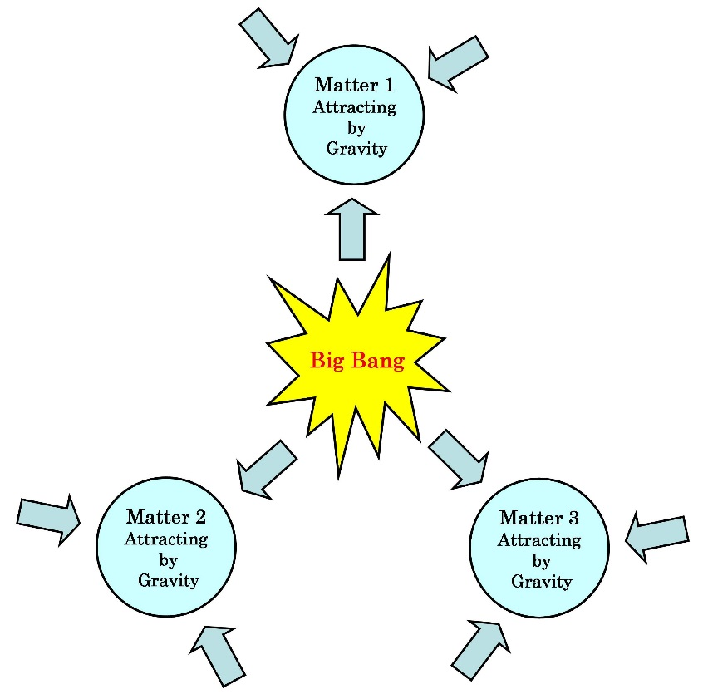
When there was no universe in this world, there were souls only. Souls made universe. They started making matter and energy from souls themselves. Namely, they changed themselves into matter and energy. Matter can change into energy, and energy can change into matter. Souls made the energy and the matter in order to become happy and enjoy life. If the matter and energy are made, souls can create life. This is considered later. Essence of soul is that they basically want to be happy and enjoy life. That is their instinct or nature or essence. In other words, mind of feeling happy and enjoying is the soul itself. If we think like this, we can think how souls will mature.
Every soul is composed of Unit Soul. The composition of soul is different from soul to soul. Basically, as shown in the Figure III-2, each soul is composed of core soul and floating soul.

Figure III-2. Core Soul and Floating Soul

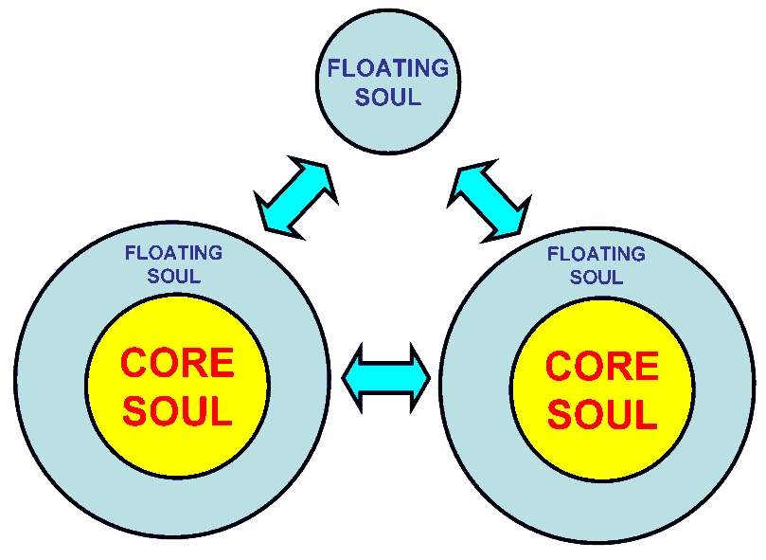

The core soul is solid, and it is not easily decomposed. The floating soul easily separates from the core soul. So, a floating soul moves from a core soul to another core soul. Each soul has an identity. A core soul of a human has a strong identity. On the other hand, a core soul which has no experience of human has no strong identity. A weak core soul may join a stronger core soul. If two core souls with equal strength are combined, it may become schizophrenia.
In the previous universe, many souls built civilizations. But their universe became uninhabitable. So, they traveled space and arrived in our universe. The maturity of souls is different from soul to soul. Basically, each soul matures gradually. In the initial stage of maturity, soul is suitable only for primitive life such as ameba. It gradually evolves to soul of higher level. Souls can decide the arrangement of DNA. So, souls can make life evolve. If brain evolves, the brain accepts bigger souls. Finally, soul matures to a level of human. When a human died, the soul of the human must leave the body of human. If she or he can enter a body of human, she or he is reincarnated into a human again. Usually, when a human dies, her or his soul is separated into the core soul and the floating soul. So, the size of soul shrinks. So, smaller soul can enter animals with smaller brain. For example, when a human died, the soul of human will shrink and can enter into the body of horse or cow. When a soul of dead human cannot enter a life, the soul shrinks day by day. If a soul committed crime like killing human, she or he cannot join another good human. So, she or he shrinks day by day. Finally, she or he must become matter or energy. This means that she or he fell into the hell. In the Spirit World, souls gather together and combine together. So, some souls become too big for human brain. They can enter brain of human when human has evolved and has got a brain that is big enough to accept the big soul. Namely, this is the evolution of human being.

IV. POWER OF SOUL

If we want to be happy and enjoy life, we should think of the essence of our soul. I think, soul has following abilities.

1. Soul can keep character, important memories, talent, religious mind, etc. even after reincarnation.
2. Soul can create life.
3. Soul can control the body of life.
4. Soul can make life evolve by affecting the arrangement of DNA.
5. Soul can affect the reincarnation of other souls. So, the reincarnation of each soul is affected by other souls.
6. Soul has the power of gravitation. So, soul can, by combining each power, make the universe. Orbit of planet is maintained by the gravitational power of souls.

These are explained in more detail as follows.

1. Soul can keep character, important memories, talent, religious mind, etc. even after reincarnation.

Souls is in the brain. But the brain is not the soul. Nerve of brain is the corridor or route of soul. Soul moves through the nerve of brain. Or, souls exchange information through the nerve. Hereafter, we think souls combine together through the nerve. Soul moves from a soul to another soul and two or more souls combine together. If souls combine together, they can think or feel new things. For example, when a person met an old friend, she or he tries to remember the name of friend. Sometime, she or he cannot remember the name of friend. In this case, the core soul of the person tries to remember. But the soul that has the memory of the friend cannot reach his core soul. So, the person cannot remember the name. This may be because the nerve is no good, so the soul with the memory of friend’s name cannot reach the person’s core soul. Or, the soul with the memory of name has become too weak, and so the soul cannot keep the memory of name. Furthermore, when separate souls combine together, a new idea emerges in mind. Sometimes, a soul with new idea that came from the outer space may join the soul of a person. In this case, inspiration of genius may emerge. Inspirations of genius such as Edison or Einstein emerged like this. Anyway, when separate souls combine together, something new happens.

2. Soul can create life.

Origin of life was made by soul. Even if the earth is destroyed or becomes uninhabitable, soul will travel universe and finally find inhabitable planet. At first, souls can create primitive life such as ameba. Arrangement of DNA must be evolved when the ameba evolves. Soul can evolve the arrangement of DNA. Life evolves very slowly and, finally, reaches the human level.

3. Soul can control the body of life.

We can walk, eat, sleep, etc. This is because soul orders our body to do so.

4. Soul can make life evolve by affecting the arrangement of DNA.

It is said that evolution is possible following the change of arrangement of DNA, and this change occurs by the accidental mutation. This accidental mutation can cause a slight evolution of same species. But this accidental mutation cannot cause the evolution from a species to another different species. For example, red flower emerges from the seed of white flower. This is the result of accidental mutation. But, evolution from a cat to a dog cannot be caused by the accidental mutation. Here, the relation between cat and dog is that no baby is born between cat and dog. Namely cat and dog are different species. We are considering the evolution from a species to another species. If an evolution from a cat to dog was caused by the accidental mutation, there must be an intermediate species between the cat and the dog. Namely, a baby is born between the cat and the intermediate species or between the dog and the intermediate species. But there is no such species. So accidental mutation cannot cause evolution from a species to another species. Then, what force caused the evolution from cat to dog or from dog to cat? Souls caused the evolution.

5. Soul can affect the reincarnation of other souls. So, the reincarnation of each soul is affected by other souls.

When a soul in the Spirit World is reincarnated into a life such as cat or dog or human, the soul must get the permission or cooperation of other souls. So evil souls cannot enter healthy body of life.

6. Soul has the power of gravitation. So, soul can, by combining each power, make the universe. Orbit of planet is maintained by the gravitational power of souls.

This power is to attract matter and to push away matter. In many cases, we see only attracting power. The earth is revolving around the sun. The orbit of earth is maintained for billions of years. This is because soul is maintaining the orbit. The orbit of earth cannot be maintained without the support of soul. Satellite orbiting around the earth falls to the earth sooner or later. This is because the satellite is not maintained by the gravitational power of souls. On the other hand, gravitational power of soul can be combined and can maintain the galaxies.
These are basic power of soul.

V. HISTORY OF SOUL

We should think of the history of maturity of souls. Souls have matured and evolved for eternal period. Origin of souls is not in our universe. The origin of soul emerged when there was no universe. Souls created the universe by changing themselves into matter and energy. When souls are in other universes, they matured to some extent. But their planet became uninhabitable or disappeared. So, the souls had to travel universe and look for inhabitable planets. After they reached an inhabitable planet, they could make very primitive lives such as ameba. They could not make sophisticated lives such as horse, cow, human, etc. Souls of large size could not enter small lives such as ameba. So, they had to wait until more sophisticated life is born.

1. Universes Other than Our Universe

It is said that the Big Bang occurred 13.8 billion years ago. That was the birth of our universe. But, before the Big Bang, there were numerous universes. It is said that, in a universe, there are trillions of galaxies, and in a galaxy, there are billions of stars or more.
Who made these universes? The beginning of universe is the soul. Before the universes were formed, in the Spirit World that is composed of souls, they wanted to be happy and enjoy life. But they were in the Spirit World. Namely, there was no universe. Only the souls were existing. They could not think but could feel something instinctively. They instinctively felt that they want to feel happy and enjoy life. So, some of them became matter and energy. The matter and the energy made the universe. Galaxy is maintained by the gravitational power of soul. Also orbit of planet around the sun is maintained by the gravitational power of soul. Souls made the life. Souls can decide the arrangement of DNA. Evolution of life depends on the arrangement of DNA that is decided by soul. Evolution is not decided by the accidental mutation of arrangement of DNA. Accidental mutation of DNA causes only minor evolutions among same species. For example, babies are born between the German Shepard and the Golden Retriever. This is because they are in same species. But no baby is born between a cat and a dog because their species are different. Evolution from cat to dog or from dog to cat cannot occur by accidental mutation of DNA. This can be shown mathematically. Combination of DNA runs into astronomical numbers. So, it is impossible that accidental mutation of DNA can cause evolution from a species to another species.
There are many universes around our universe. Our universe was born around 13.8 billion years ago, and our Earth was formed about 4.5 billion years ago. On the Earth, human-like apes appeared about 5 million years ago. When a large size soul came from other universe to the Earth, it could not find the body of life to enter. So, it had to wait outside the life. While it was waiting, the size of soul shrank day by day because the floating soul separated every day. But finally, some of the big soul could enter a life because the size of soul shrank or many lives evolved and so the lives could accept larger souls. Even now, some souls are too big to enter a life. They are waiting to shrink or to find a life large enough for them. Such souls can enter a life when a life has evolved enough. Namely, they are more sophisticated than any souls in life.

2. Way of Living

We start this section from the age when letters began to be used in Ancient Egypt in BC period. We can classify souls into following several types.

Type 1. Basically, this type of soul is ordinary.
Type 2. Souls of this type are interested in the politics. They want to rule society.
Type 3. Souls of this type are interested in science.
Type 4. Souls of this type are interested in music, art, literature, etc.
Type 5. Souls of this type are interested in business.
Type 6. Souls of this type are interested in sports.
Type 7. Souls of this type are interested in adventure.

In the age when there was no letter, character of souls was not so different. But, after letter was invented, souls of people began to diversify. Basic power of soul is the mind that want to be happy and enjoy. This power, at least in the present age, cannot be analyzed scientifically. This mind that wants to be happy and enjoy life is the cause of evolution or maturity of soul.
Souls of first type, namely, ordinary souls were not so different from animal. They do not do particularly positive things.
Souls of second type are interested in politics. So, they tried to rule their small community. They become the head of village. Basically, they became the head of society relying on the violence. They beat other people and became a leader. In the present world, each country is maintained by military force. For example, USA, China, Japan are maintained by military force.
Souls of third types were intelligent people. They like studying many things. Science has been developed by them.
Souls of fourth type like music, art, literature, etc. They do not think scientifically. They achieved many valuable works in these field.
Souls of fifth type are interested in business. They are interested in earning money.
Souls of sixth type are interested in sports. They like physical training.
Souls of seventh type are interested in adventure. They want to go to strange places.
Thus, there are some types of character of souls.

3. Major Religions

In the age of BC period, there were not many people on the earth, and there were some civilizations in some parts of world. In BC period, one of the most important persons was Buddha. He was the originator of Buddhism. He was born around 563 BC. It is said that Buddha got the enlightenment when he was 35 years old. In the state of enlightenment, we are freed from any suffering and will never be reincarnated. But we do not know the clear situation of enlightenment. Does the enlightenment mean that we have become perfect?
With regard to this thought, I have a different opinion. In the state of enlightenment, Buddha discovered the way how to become happy. He realized what he has to do to be happy and got the spiritual strength to do what he has to do. This is the enlightenment. It is very simple. In the state of enlightenment, we instinctively feel that next life will be improved as compared with present life. For example, if a blind man is reincarnated into a healthy man, this is the improvement of life by reincarnation. In a word, Buddha taught people how we must live in order to be happy and enjoy life. So, many people followed him. He said that he will not be reincarnated after his death. He felt like that. But this was wrong. We cannot decide our reincarnation. Some people must be reincarnated even if they do not want. For example, nobody wants to be reincarnated into a handicapped person. Or, some people cannot be reincarnated even if they want. Some people must change into matter or energy. This means that they must go to hell. It is said that we must be burnt in the hell. For example, if souls are in the sun, they are burnt. We instinctively remember it.
After Buddha, another important person was born, Christ. Needless to say, it was around A.D. 1. He was thought of as the Messiah prophesied in the Old Testament. He died in his thirties. His teaching has been spread all over the world. Population of Cristian is 2 billion or more. It is the largest religion in the world. Major religion in the scientifically advanced countries is the Christianity. For example, in USA and European countries, major religion is Christianity. Namely, religion of most powerful countries is Christianity.
Also, an important person Muhammad was born around 570. He was the founder of Islam. Population of Islam is close to the Christianity. But the growth rate of population of Islam is higher than that of Christianity.
Needless to say, there are numerous other religions. But, these three religions are definitely affecting the life of people in the world. Religion is the philosophy on how we can be happy. But, basically, religions cannot establish the peace in the world. This is because people of these religions give priority to the violence rather than to the dialogue. So, we need a thought of new generation. This is the thought of World Citizen.

4. Some Important Souls

There are some important people in the world. We should think of their souls. I think character of people depends on their former life. Some people are aggressive and seek for power. They cause war to rule other people. They do not respect the dialogue. Some people like peace. They hope for dialogue instead of war. What is the reason for this difference? This difference depends on their former life. If their former life is plant-eating animal, they are not so aggressive and like peace. If their former life is flesh-eating animal, they are aggressive and like war. For example, if a former life of a person is lion, she or he is aggressive and likes war. The Presidents of USA, are, in general, descendants of flesh-eating animal. In general, most political leaders are descendants of flesh-eating animal. But some people are descendants of plant-eating animal. For example, Mahatma Gandhi is a descendant of plant-eating animal. He led India to the independence by the policy of non-violence and disobedience in 1947. In the present world, most political leaders are descendants of flesh-eating animal. In the human history, most political regimes were established by the winners of war. USA is a very good example.

VI. FUTURE OF SOUL

We have considered the history of souls and the present situation of souls. Then, we must consider the future of souls. Each Unit Soul has a desire to be happy and enjoy life. So, every soul has a same desire. This desire or energy is the source of every life. This is the power of soul or spirit. At present, this power or energy cannot be analyzed scientifically. This power causes the evolution of souls. Then, how will souls evolve? What is the basic direction of evolution? Will human being become smarter? The most interesting and important question is why there are woman and man in this world. A question why we want to have sex is also interesting and important. We feel happy and unhappy. We feel happy when we have sex, play interesting things, eat tasty meal, get money, etc. On the other hand, we feel unhappy when we have no partner for sex, cannot enjoy interesting things, cannot eat tasty meal, cannot get money, etc. Why do we feel happy or unhappy? When we have an operation to cure a disease, we are anesthetized and we feel no pain. Why do not we feel pain under anesthesia? These things will be considered in this section.

1. Directions of Evolution of Soul

Then, let us consider the basic direction of evolution of soul. Basically, soul is maturing day by day. Every day, floating souls are joining to core soul. The relation between woman and man is the most important because we must get old and die and there are woman and man in this world no matter how the science develops. In a word, in the future, the common sense about the woman-man relation will be that sex is allowed after the marriage. We will consider this issue later.
Then how will be the soul of people of ruling class of country? Now, generally, rulers of country are maintaining the regime by military forces. Present situation of regime of world was established through the World War II. Italy, Germany, and Japan were defeated by military power. Present situation was not established by the dialogue. Still, people in the ruling class are trying to rule the world by the military power. They do not try to establish the World Federation. This is mainly due to their experience in their former life. Their experience in former life was not only on the Earth but also on other planets in other universes. Namely, they lived in other planets also. They have no experience of ruling the world by the democracy based on the dialogue. On the other hand, some people are trying to rule the world by peaceful way. In their former life, they lived on planets that were ruled by peaceful democracy. So, they are trying to establish the World Federation. But their number is small as compared with the people who do not respect the dialogue.
Then what direction will souls evolve to? All the souls are maturing day by day. But there is a common direction of evolution of all the souls. One of the common directions is that the intelligence of human rises further following the evolution. But there are other aspects of souls. The most important aspect is the attitude for woman-man relation. There is no common sense for the woman-man relation in the present world. Basically, in the countries of Christianity such as USA, European countries, or in a country of Buddhism like Japan, etc., woman-man relation is free and so love and sex are free. On the other hand, countries of Hinduism and Islam such as India, Iran, Iraq, etc., love affair before marriage is not allowed. Sometimes people are killed for their love affair against the Hinduism or Islam. This killing is called the Honor Killing. It is said that there was no Honor Killing in the age when there was no movie and TV. Before the age of movie and TV, woman-man relation was traditional and healthy. So, there was no Honor Killing. In movie and TV, woman-man relation is neither traditional nor healthy, and so many people have sex without marriage. Many people were affected by this behavior and imitated it. As a result, atmosphere of society has become lonely and empty. People in countries of Hinduism and Islam cannot accept this culture. So, the Honor Killing has emerged. In these countries, sometimes, TV is destroyed, movie theater that runs movie of homosexual love is burnt, people who had sex without marriage is killed, etc.
Thus, there is no common sense in the world about the woman-man relation. But, in the future, a common sense will be born. Namely, woman-man relation will become healthy. In other words, sex without marriage will not be allowed. This is a basic direction of evolution of soul. So, we can say that Hinduism and Islam is more advanced than the Christianity and the Buddhism with regard to woman-man relation. In science, countries of Christianity and Japan is more advanced than countries of Hinduism and Islam. But people in countries of Hinduism and Islam think that they are more advanced with regard to woman-man relation. In private daily life, in general, people in countries of Hinduism and Islam are feeling happy while people in counties of Christianity and Japan are feeling lonely and empty.
Then, what about the attitude of soul for politics? Now, the world is ruled based on the military power. USA attacks other countries without the approval of United Nations. For example, the President of Iraq, Saddam Hussein, was captured and executed in 2006. On the other hand, supreme leader of Libya, Muammar al-Gaddafi was killed in 2011. Islamic State was born in 2014 because USA destroyed the regime of Iraq and Libya. Hussein and Gaddafi were removed because they did not follow USA. North Korea does not want to become like Iraq and Libya, so they are developing nuclear weapons. USA attacks other countries by the military force. This action shows the degree of maturity of soul of political leaders in USA. If souls of people are matured to certain extent, it seems that the world can be ruled by peaceful mind. Are there such countries in the world? For example, India is close to this type of country. Mahatma Gandhi lead India to the independence in 1947 by the policy of non-violence and disobedience. We should learn from this policy.
Brain is a complex of many neurons. Neuron is not the souls. Neuron can hold souls and is a path of souls. When two souls are combined together, the combined soul can feel something. For example, when our hand is injured, we feel pain. But we do not feel pain when we are under anesthesia. This is because soul cannot reach our brain due to anesthesia. If soul wants become bigger, namely, if separate souls want to combine together, they need bigger brain. This needs the enlargement of brain. Enlargement of brain can be done after evolution.
In Sub-Section 2. Way of Living, Section V. HISTORY OF SOUL, seven types of souls are considered. The reason why there are such different types can be explained by showing the direction of evolution of souls. So, let us see the mechanism of reincarnation in more detail.
Basic mechanism of reincarnation is that souls are reincarnated from the Spirit World to life. Souls have a desire to enjoy. So, they want to enter a life. In the Spirit World, there is no pain, no suffering, no hardship, etc., but there is no amusement also. In our actual world, we can eat tasty meals, have a sex, do many things, etc. These cannot be experienced in the Spirit World. So, souls want to be reincarnated into life. Soul can be reincarnated when she or he is helped by other souls. If a soul did good in her or his former life, she or he is helped by many souls, and so she or he is reincarnated happily. For example, she or he is reincarnated into a talented and beautiful person. If a soul did bad things, she or he is reincarnated unhappily. For example, she or he is reincarnated as a handicapped baby. This is a basic mechanism of reincarnation.
Then, how should we think about Buddhism? It is said that Buddha, who was a founder of Buddhism, got the enlightenment and was emancipated from worldly desires and worries. He said that he will not be reincarnated. I cannot believe this. If we are emancipated from worldly desires and worries, in what situation are we? I think, we have no joy when we have no worries. I imagine that Buddha felt that he has solved any problems in his life. Basically, I think, Buddha realized what we must do to be happy. He got spiritual strength essential to be happy. So, he was happy and taught many people what we must do to be happy. Many people succeeded his teachings and diffused Buddhism. As for the reincarnation, he felt that he will not be reincarnated again. But, we cannot decide whether we are reincarnated or not.
There may be a man like Buddha. But I have never seen such a man. In the Spirit World, there is no suffering, but there is no joy also. So, souls do not hope for such situation. Souls want to be reincarnated to enjoy. Reincarnation does not happen equally to all the people. Some people are reincarnated within a week. Some people are reincarnated after one thousand years. Some souls change into matter or energy without reincarnation. Buddha repeated reincarnation many times. But Buddha’s waiting period for reincarnation was very short such as on week. After he got enlightenment, he felt that he will not be reincarnated soon. This happens in ordinary people also. So, he said that he will never be reincarnated.
But, as far as final situation is concerned, Buddha was wrong. In other words, about the situation of enlightenment, Buddha’s explanation is wrong. We cannot be happy and enjoy anything in the world without worldly desires and worries. In the Spirit World, there is no pain, but there is no joy also. We want to enjoy life. So, we want to be reincarnated to enjoy. So, Buddha was wrong in this point.
Very few souls may become like Buddha. But, at present, most souls are not like Buddha. So, we should not aim to become like Buddha. We should aim to improve our character. By improving our character, our next life will be better than present life.

2. How Should We Live?

There are many types of human soul. Basically, roots of soul are from the flesh-eating animal or the plant-eating animal. People whose former life was the flesh-eating animal is strong and aggressive. They want to solve problems by war. On the other hand, people whose former life was the plant-eating animal is not aggressive. They like peace.
Souls who support the World Federation came from planets where there was the World Federation. Souls who do not support the World Federation came from planets where there was no World Federation. In the future, souls who support the World Federation will increase. Basically, we want to be happy and enjoy life. So, we must think earnestly and make efforts if we want to be happy. The efforts make our soul mature. If a soul does not make efforts, the soul will not mature. So, a person who does not make efforts does not grow spiritually. For example, if a man has a training of marathon, he has to run and it is very hard. He spends a lot of energy, and this draws souls from outside. This souls from outside mature his soul. If a man is lazy and does nothing, his soul does not draw better souls. So, his soul does not mature. Thus, if we want to be happy and enjoy life, we must make efforts.
Then, what should we do actually? Needless to say, there are many things we should do. There are works such as scientific research, political activity, arts, music, manufacturing industrial products, making agricultural products, education, etc. Here, our consideration is mainly limited to political and economic problems only. This is because, in the present world, it seems that the most serious problems are war, poverty and destruction of environment. Here, we are mainly concerned with war and poverty.
Why doesn’t war disappear? Basic reason is the level of maturity of soul. If soul is matured enough to a certain level, leaders of politics will not start war without sufficient dialogue. The most effective instrument of maturing the soul of people is the World Parliament. Through dialogue in the World Parliament, parliament members will know each other. They will understand the truly good things. Here, the World Parliament is composed of members directly elected from each country in proportion to its population.
We should try to mature our soul. There are many things to do to accomplish this object. Those who are doing good have a good character. On the other hand, those who are doing evil cannot have a good character. This is because good souls will join us if we do good, and bad souls will join us if we do evil. In the field of world politics, we should try to establish the World Federation. This is a good thing, so this will make our soul mature.
In the present world, leaders of world politics do not love people in the world. Needless to say, they have love for their family and for people in their country. But leaders of powerful countries do not love people in other weak countries. They treat people in weak countries as livestock. So, we must educate young people to have love for all the people in the world.
Here, let us see a prospect of maturity of soul. Prospect is considered from the viewpoint of maturity of soul for each country such as India, China, USA, Japan, etc.

3. India

One of the oldest civilizations emerged from India. In the present age, major religion is Hinduism, and people in India like peace. They call themselves “Peace Loving Nation”. I studied economics as a student of Ph.D. course in the Delhi School of Economics of the University of Delhi from 1985 to 1987. Woman-man relation of present age does not seem so different from 1985 to 1987. Most students in university had no sexual experience. It seems that one out of ten students or one out of hundred students had relation with prostitute. In India, there is a custom of the Honor Killing. This is a murder committed by relative or family. For example, if a woman got divorced, she is killed by relative. It is said that hundreds of people are killed by Honor Killing in a year. Furthermore, mind of vegetarian is important. Vegetarian do not eat meat. But they eat egg and drink milk because they do not kill animal by eating egg and drinking milk. Namely, they do not like killing animal. People like peace and do not like killing animal. Mahatma Gandhi led India to the independence by the policy of non-violence and dis-obedience. With regard to money, it is said that corruption is not rare.
When we see India from the viewpoint of maturity of soul, as far as woman-man relation is concerned, Indian people are most matured in the world. It is said that if a young man has a relation with prostitute, he is shielded by his family. In general, most women and men have no sexual relation before marriage.

4. China

In China also, one of the oldest civilizations emerged. The Analects of Confucius is one of the most famous books in the world. It was written by Confucius (551-479 BC). His thought is still affecting Chinese people. Needless to say, China has the biggest population in the world. This means that the leaders of China is very powerful. In India and China, leaders are strong, so India and China have become big countries. Basically, leaders of Indian and China can prevent the state bankruptcy. Leaders of country are like that of company. If leaders are excellent, the company grows. Also, if leaders of country are excellent, the country becomes big like India and China.

5. USA

In USA, history of high-level civilization is very short. Columbus discovered islands near USA in 1492. Now, USA is the top of world in many fields such as science, economy, military forces, etc. Needless to say, USA is a country of democracy. USA carried out many wars. Many of wars were conducted without the approval of United Nations. Leaders of USA do not love people in the world. They are treating people as livestock.

6. Japan

In Japan, people were living since Stone Age. I was born and living in Japan. The oldest literature in Japan, Kojiki, was written in 712. One of the most important features of Japanese culture is the emperor system. It is stipulated in the Constitution of Japan that the emperor is the symbol of Japan. Emperor existed since before 712 when the oldest literature in Japan was written. It is said that about 80 percent of people support the emperor system. Naturally, politics and religion are not divided in Japan.
One of the most important problems of Japan is the state bankruptcy. In 708, the first coin was coined. So far, state bankruptcies sometimes occurred. The first state bankruptcy occurred in 1297. Feudal government of Japan issued an order to cancel the debt. In 1333, 36 years after the order of cancelation, the then feudal movement collapsed. In the next feudal government, an order of cancelation was issued in 1441. In 1467, 26 yeas after the order of cancelation, Japan entered into domestic war period. In that period Japan was in the state of anarchy. In the period ruled by next feudal government, in 1841, the order of cancelation of debt was issued. In 1867, 26 years after the cancellation order, the feudal government collapsed.
Thus, there were some state bankruptcies in the history of Japan. Now economy of Japan is in the state close to the state bankruptcy. This problem can be solved by the policy of dividing the religion and politics. Namely, this policy is to abolish the emperor system and introduce the president system. In the country where the religion and politics are not divided, politicians who support the emperor system win the election. They worship the emperor without respecting the truth and loving people. So, they cannot do revolutionary politics. By dividing the religion and the politics, political leaders who can prevent the state bankruptcy can win the election and get the power.
Then, when will the emperor system be abolished? When one of the three following incidents occurred, the debate for politics of Japan that includes the abolition of the emperor system will occur among ordinary people.

1. When a motion of amending the constitution is made to the National Diet.

2. When the state bankruptcy occurred.

3. When the U.S.-Japan Security Treaty is denounced and the U.S. troop withdraws from Japan.

But the emperor will continue to exist after the abolition. I personally hope that the emperor will become a head of religious corporation in the private sector and issue a prize bigger than the Nobel Prize.

7. Roots of Each Nation on Other Planets

Here we can imagine the roots of each nation before they came to the earth. As for souls of Aryan, they came to earth from another planet that was in our universe or other universe. Let us call the planet the Planet Aryan. As for planet of Chinese, Anglo-Saxons, and Japanese, we can call them the Planet Chinese, the Planet Anglo-Saxons, and the Planet Japanese respectively.

A. Roots of People in India

Basically, people in India love peace. Thirty percent of people are vegetarian. They do not eat meat but drink milk and eat egg. Some people feel this is ridiculous. We can understand this if we understand that drinking milk and eating egg do not kill animal. Actually, they can drink milk and eat egg because drinking milk and eating egg do not kill animal. Namely, people of vegetarian have a mind of No-Killing-Animal. They came from Planet-India.
Basically, leaders of India can prevent the state bankruptcy. This point is different from the leaders of Japan.
People in India have a high pride. In daily life, we must experience many cheating about money. For example, a student from USA to university in Delhi, India, applied for hostel room in university. Staff of the hostel made him wait for one month. After one month, the staff required bribe for the room. The student got very angry but did not pay the bribe and rented a room near the university. This kind of cheating often happens in India. It is a little strange that people like this have a high pride. But with regard to woman-man relation, it is very strict. Some people are killed when they do not follow the doctrine or teaching of Hinduism or Islam. When people divorced, some people are killed. This is called the Honor Killing. Thus high pride of Indian people are based on the strict woman-man relation.

B. Roots of People in China

Soul of Chinese people came from Planet Chinese. History of Chinese culture is very old. Basically, leaders of China can prevent the state bankruptcy. This point is different from the leaders of Japan. So, China can be unified under one authority. There are some violent people among ordinary people. So, they do not follow the law sometimes. Under this situation, democratic election is difficult. In Taiwan, election is democratic. But, there is the US troop in Taiwan.
In Hong Kong, some political problems are reported. Some activist require democratic election. But they sometimes commit violence. So, they are arrested. So, Leaders of USA condemn this. But we must not forget that China has 1.4 billion people. If USA has 1.4 billion people, there will be uprisings severer than those in China. This is because leaders of USA are treating people as livestock. Leaders of China have deeper love than leaders of USA.
Then how can we conduct democratic election in China. Dictatorship by Communist Party cannot elect leaders by democratic election. Basically, international political party like World Party is necessary.

C. Roots of People in USA

People in USA are composed of many races. But leaders are mainly Anglo-Saxons. Basically, leaders of USA can prevent the state bankruptcy. This point is different from the leaders of Japan. Their soul came from Planet Anglo-Saxons. Before American Continent was discovered, Great Britain was the land of Anglo-Saxons. Democracy was established in Great Britain and spread to world. Anglo-Saxons invented many things. Their descendants emigrated to North American Continent and build USA, economically and militarily the most powerful country in the world. Needless to say, in the field of science, USA is the most advanced country.
The most important problem of Anglo-Saxons is the lack of love to people. Leaders of USA are Anglo-Saxons and they are treating people as livestock. For example, USA insisted that there are weapons of mass destruction in Iraq and occupied Iraq without approval of United Nations in 2003. President of Iraq, Saddam Hussein, was executed in 2006. Also Libya was attacked without approval of United Nations, and the leader Muammar al-Gaddafi was killed in 2011. After these incidents, Islamic State emerged.
In USA, there are many fantastic and stimulative events and incidents. But in the daily private life in USA, people are feeling that life is empty or lonely. We cannot be happy and enjoy life alone. This point must be improved. It is done by ordinary people not by government. So, people in USA must learn about human love.

D. Roots of People in Japan

Roots are different, and so, characters are different. Basically, most Japanese came from the Planet Japanese. Their character is basically diligent. Hard work of Japanese is famous in the world. They are excellent in manufacturing goods. So, Japan is making many industrial products. Incidentally, from my experience in trip in Nepal, people in Nepal are also excellent in making goods. Leaders in Japan are people who worship the emperor. They have been ruling ordinary Japanese people for more than 1,000 years. So, politics and religion are not divided. Another important feature of Japanese politics is the state bankruptcy. It sometimes occurred in the history of Japan as shown below.
Basically, the result of the combination of politics and religion is the politics of savages. Here, two examples are mentioned. First example is that Japan withdrew from the League of Nations in 1933. The second important example is the state bankruptcy that will come in the near future.
The first example is as follows. The most important incidents in this age were

1931: Manchurian Incident
1932: 5-15 Incident. Prime Minister Tsuyoshi Inukai was murdered.
1933: Withdrawal from the League of Nations
1936: 2-26 Incident. Finance Minister Korekiyo Takahashi and others were murdered.
1939: World War II
1941: In November, USA presented the Hull=Note that required concessions such as the withdrawal of Japan from China and Vietnam. In December, the Pacific War.
1945: The end of the war. Next year, announcement of the Constitution of Japan. Emperor became the symbol of Japan.

In this age, Japan advanced to Asia step by step. When Japan advanced to Manchuria in China and caused the Manchurian Incident in 1931, the Chinese Nationalist Party appealed to the League of Nations (hereafter, the League). The League, accepting this, dispatched the Lytton Investigation Committee to Manchuria.
On the other hand, in Japan in 1932, 5-15 Incident was carried out by young officers of the navy who support the emperor and Prime Minister Tsuyoshi Inukai was murdered. In 1936, 2-26 Incident was carried out by the young officers of the army who support the emperor, and VIPs of government such as or Finance Minister Korekiyo Takahashi and others were murdered. Although the rebel armies were suppressed and punished, these incidents made the parliamentarism powerless and Japan proceeded to the militarism. We can think that if the powerful troop like US troop were staying in the country, 5-15 Incident and 2-26 Incident did not occur and the democracy did not collapse. Japan and Germany are same in the point that the democracy which was established to some extent collapsed.
On the other hand, in 1933, the general assembly of the League passed, with favor 42 : objection 1 : abstention 1 (the objection is Japan and the abstention is Thailand), the advisory opinion toward Japan which required the withdrawal from Manchuria and other concessions. But Japan withdrew from the League. There is an opinion that, in 1941, USA came up with the Hull=Note which contained the unacceptable requirements such as withdrawal from China and Vietnam, and so Japan had to open the war against USA. But we must not forget that at the point of withdrawal from the League, Japan had already been on the route of invasion. On the other hand, in the present day, Japan has become a democratic and peaceful country. But they are the democracy and peace under the presence of US troop in Japan based on the US-Japan Security Treaty. Namely, the democracy and the peace of Japan is not maintained by the force of Japanese itself. If the Security Treaty is denounced and the US troop withdraws from Japan, Japan will enter into the situation under which military coups like those in prewar period may occur, the parliamentarism loses its power, and the militarism may come.
The second important result of combination of politics and religion is the state bankruptcies occurred under the politics that worship the emperor. Main bankruptcies are as follows.

1297: Kamakura Shogunate (Japan's feudal government at Kamakura) issued the Tokuseirei (an order of cancelling debts).

1333: Thirty-six years later, the Shogunate collapsed.

1441: Shashaku (people engaged in transport business by renting wagons), Bashaku (people engaged in transport business by renting horses), and farmers got the Tokuseirei from the Muromachi Shogunate (Japan's feudal government at Muromachi, Kyoto).

1467: Twenty-six years later, The War of Ohnin began in 1467 and the country entered into the Age of Civil Wars (1467-1590).

1841: Tadakuni Mizuno of Edo Shogunate (Japan's feudal government at Edo (present: Tokyo)) who implemented the Tenpo Reform from 1841 issued the Kienrei (an order of cancelling debts) and exempted a part of debts of Hatamoto and Gokenin (direct and low-grade retainers of Shogun who was the commander-in-chief of an expeditionary force against the barbarians and was the head of the Shogunate), and tried to extract a huge amount of government funds from merchants. These government funds were, as it were, forced public bonds because they were to be refunded with interest. Furthermore, he issued a great amount of money by lowering the quality, and so the inflation occurred.

1867: Twenty-six years later, the Shogunate collapsed.

Considering like this, we can see that the present age resembles very well the age when a regime collapsed and a new regime emerged. Namely, in the present age, the deficit of the national finance is swelling, and the state is going bankrupt. It is said that the debt of state is about 260% of GDP in 2021. The Abe Cabinet, that started in 2012, took an easy-money policy. This policy is not essentially different from the Tenpo Reform, and the result is clear. In Kamakura Period (1192-1333), Muromachi Period (1336-1467), and Edo Period (1603-1867), Shogun was appointed by emperor and ruled Japan, and in these periods, the Tokuseirei or the Kienrei were issued. Emperor is hereditary and so people around the emperor was also hereditary, and this made the state go bankrupt. In the present age, government corresponds to the Shogunate, and the state bankruptcy similar to that in the feudal age is going to happen. This is the traditional politics of Japan. In other words, politics of Japan is the politics of savages. Japan is an island country. So the politics has become a politics of savages.
In 2021, Prime Minister Abe resigned and the Prime Minister is Mr. Suga. Still, policy of Japan is same and Japan is going to bankrupt. Thus Japan is going to state bankruptcy wile India, China and USA can prevent it.

8. In the Future

We have seen basic features of four countries. Then, let us consider the future of each country. USA is, economically and militarily, the most powerful country in the world. So first of all, let us consider the future of people of USA. In the politics, USA is treating people in the world as livestock. For example, in 2003, USA invaded Iraq insisting that Iraq has weapons of mass destruction. This was implemented without the recognition of United Nations. Finally, Iraq was occupied and the President of Iraq, Saddam Hussein, was captured and executed. In this war, it is said that hundreds of thousands of people were killed. Iraq has a large deposit of oil. This was the target of USA.
This is due to the mind that treats people in the world as livestock. Then, how will people of USA be treated after the reincarnation. After we die, our soul leave our body. The soul stays around us but we cannot see it. Each soul wants to be happy and enjoy life. So they want to enter body of life. But when soul enters a life, it needs help or approval of other souls. So, behavior of soul in previous life is important. If someone did good, many other souls will be thankful to him. So they will help him to be reincarnated into a healthy person. Let me explain this case by an example. I can write two stories of two persons. One is a woman, Hanako, and another is a man, Hiroshi.

Hanako's Story

Hanako is an ordinary woman. She worked earnestly. She got married and had two children. Working earnestly is not special thing. But, it is much better than committing crimes. She is not a great person but a good person. She died due to age and her soul left her body. She stayed in the Spirit World for 100 years. Again she got a chance to be reincarnated into a human and enjoy life. At this moment, other souls played a very decisive role. In the Spirit World, ever souls know each other. Ever souls know what Hanko did in her previous life. She did not do great things but worked earnestly. So, other souls allowed her to be reincarnated into an ordinary person. She was born as a heathy girl. In this life also, she will be happy and enjoy her life.

Hiroshi's Story

Hiroshi is not an ordinary man. In a word, he is an evil person. He killed some people for money. He committed a robbery and killed a whole family to take money. He was shot to death by police. So, his soul entered the Spirit World. After hundreds of years, he got a chance to be reincarnated into a human. Like other souls, he wanted to be happy and enjoy life. So, he was always waiting for being reincarnated. But, in case of Hiroshi also, permission or cooperation of other souls was necessary to be reincarnated. Here, his behavior in his previous life was a big problem. He killed people for money. So, it was impossible to get positive permission or cooperation from other souls. He was reincarnated into a handicapped boy. He had no leg. So, he had to live a hard and unhappy life. This was the result of his behavior of his previous life.

Like these two examples, behavior of our previous life affects our present life. Then, how will the next life of leaders of USA be? Many forecasts are possible. In USA, there are many people such as politicians, scientists, entrepreneurs, artists, athletes, etc. Here, we consider politicians only. Especially, we consider the Presidents of USA. How will the next life of the Presidents be? After they die, they will be treated like other ordinary souls. Namely, if they did good, they will be treated warmly and will be reincarnated into healthy human. But if they committed crimes, they will be punished. Basically, they are supported by people in USA. But, in the world as a whole, they are not loved by people. So, when they are reincarnated into next life, some souls will help them and some souls will revenge them. For example, Islamic activists attacked World Trade Center in New York in 2001 and thousands of people were killed. USA attacked Afghanistan in retaliation for this. This retaliation was reasonable in a sense though the retaliation was done without the approval of United Nations. But, in 2003, USA insisted that Iraq has weapons of mass destruction such as chemical poisonous gas or bio-chemical weapons. USA and some allies invaded and occupied Iraq. It is said that hundreds of thousands of people were killed by this war. The weapons of mass destruction were not found. Finally, Saddam Hussein, leader of Iraq, was executed in 2006. This war was carried out without the approval of United Nations. On the other hand, Muammar Gaddafi, leader of Libya, was killed in 2011. In both Iraq and Libya, regimes of these countries were destroyed. On the other hand, in 2014, the Islamic State was declared. This organization implemented many terrorisms in the world. In this event, important thing is that USA attacked other countries without the approval of United Nations. Namely, they did not respect the United Nations. This is because they treat people in the world as livestock.
So, we can imagine that the then President of USA, George Bush, will be punished at the time of reincarnation. He may be born as handicapped baby. Or, he will have to experience extraordinary unhappiness.
How about the case of India? Basically, India is very poor from the viewpoint of income per capita. But India has many things to teach people in the world. We should mention vegetarian. Vegetarian do not eat meat of animal. But they take milk and egg. This is because they do not kill animal by taking milk and egg. Namely, mind of vegetarian is not to kill animal. It is said that vegetarian is about 30% of people. This mind of No-Killing-Animal is the source of happiness of people. People in India like peace. With regard to the woman-man relation, it is very conservative. Most women and men do not have sexual relation before marriage. Sometime, people are killed if they have woman-man relation forbidden by Hinduism or Islam. For example, marriage is not allowed between some castes. If someone does not follow this rule, she or he is killed. Or, a movie theater that shows movie of lesbian was burnt.
Then, which people are happier in USA or in India? This question can be answered by thinking of daily life. In USA, people are rich and level of science is high. In India, many people are poor and there are many illiterate people. But, with regard to atmosphere of society, in USA, people are feeling empty and lonely, but in India, most people are feeling happy.
How about the society of China? Also, China's civilization is very old. It is said that there are many uprisings in China. Namely, people often cause riots or uprisings. But, leaders of USA, India and China can prevent state bankruptcy. This point is different from leaders of Japan. In USA, leaders of people are Anglo-Saxons. In India and China leaders are Aryan and Han Chinese respectively. They can prevent the state bankruptcy. In Japan leaders are those who worship the emperor. So, the politics and religion are not divided in Japan and so Japanese politicians cannot prevent the state bankruptcy.
Lastly, let us consider the society of Japan. It is said that Japanese work hard. This is true. From the viewpoint of national finance, Japan has experienced some state bankruptcies. Debt of feudal government was canceled. Namely, the debt was not refunded. For example, in 1297, 1441, 1841, feudal government issued the order to cancel the debt. Namely, debt was not redeemed. After 26 to 36 years after the orders of cancelation, feudal government collapsed or Japan entered into the age of anarchy. This situation is similar to the present Japan. In Japan in 2021, debt of government is about 260 percent of GDP. Interest rate is mostly zero, so very few interest is paid. It is mostly bankruptcy. If interest rate rises, Japanese government must pay larger interest. So Japanese government must issue national bond and this will lead to the inflation. This is a pattern of state bankruptcy.
From the viewpoint of soul of Japanese, we can think as follows. Emperor is in the political system. It is stipulated in the Constitution of Japan that emperor is the symbol of Japan. Emperor is the religious entity. So, politics and religion are not divided in Japan. On the other hand, politics and religion are divided in India, China, and USA. In these countries, there is no state bankruptcy. In United Kingdom also there is no state bankruptcy. In USA and United Kingdom, leaders are Anglo-Saxons. In India, lenders are Aryan. In China, leaders are Han Chinese. In countries of these people, politics and religion are divided. In Japan, politics and religion are not divided and there were state bankruptcies in its history.
How will be the future of these leaders? After their death, they will be blessed or punished according to their behavior. It is said, in many countries, that good people will go to heaven and bad people will go to hell. For example, what will happen to leaders who invaded Iraq in 2003 without the approval of United Nations. The then President of USA was Bush. If leaders of USA are punished, they are punished by people killed by Iraq invasion. In Iraq, it is said that hundreds of thousands of people were killed in Iraq invasion. Killed people are in the Spirit World and leaders of USA will go to the Sprit World. So, the leaders will be retaliated by the people killed in Iraq Invasion. The leaders will not be able to be reincarnated into a life who will be able to be happy. For example, a Bush may be born into a handicapped baby. On the other hand, in the Spirit World, Mahatma Gandhi may be blessed by other souls. So, he will be reincarnated happily.
Among people in India, China, USA, and Japan, which people are the most matured from the viewpoint of maturity of soul? Needless to say, USA is the highest with regard to the level of science. Then, are the people in USA the most matured in terms of maturity of soul? Basically, leaders of USA are treating people as livestock. Namely they support the White Supremacism. So, if USA has 1.4 billion people like China, there will be uprising more severe than those in China. In USA in January 2021, after the election of President, some people occupied the United States Capitol for a while and four people died. They were suppressed soon. But if USA has 1.4 billion people, the result will be much more serious. In Chia, population is about 1.4 billion. But there is no serious uprisings. This is because leaders of USA treat people as livestock but leaders of China have deeper love for people. This is a matter of maturity of soul.
In general, how will the maturity of souls in the future be? As far as politics is concerned, souls will begin to love peace because they do not want to be punished by people killed by them. So, souls will accept dialogue in the world politics.

VII. WHAT SHOULD WE DO?

1. Policies Recommended

A. Division of Politics and Religion

We have considered about soul. So we can recommend appropriate policies in the world. First of all, we should consider about the division of politics and religion. It is a common sense that politics and religion must be divided. Among four countries, India, China, USA, and Japan, politics and religion are not divided in Japan only. This resulted in entering the World War II after withdrawing from the League of Nations and will result in entering the state bankruptcy of national finance.
In the politics under the emperor system, leaders preferentially apportion the budget of government to their supporters. Or, they spend the budget without following a plan. As a result, state bankruptcy occurs. Debt of government is 260% of GDP. This is the highest among developed countries. Emperor is the symbol of Japan. So, political party that does not support the emperor cannot become the ruling party. In Japan the most powerful party is LDP (Liberal Democratic Party). LDP supports the emperor system. So the politics of Japan is traditional. In other words, it is the politics of savages. LDP spends budget of government preferring people who support them. So, the bankruptcy of national finance is inevitable.
At the election, many people vote for the candidates who worship the emperor. This is because the Constitution of Japan stipulates that the emperor is the symbol of Japan. Therefore, the politics and religion are not divided. We must divide the politics and religion. Otherwise, we cannot prevent the state bankruptcy. Furthermore, in particular situation, militarism may come again. For example, Japan may become like North Kora.
On the other hand, there is no bankruptcy in India, China, and USA. This difference is due to the ability of leaders of each country. Namely, in the above three countries, politics and religion are divided. So, they can prevent the state bankruptcy without being pressured by religious forces. In Japan, leaders are people who worship the emperor. Emperor is the religious entity. Namely, politics and religion are not divided. In India, China, and USA leaders are Aryan, Han Chinese, and Anglo-Saxons respectively. Many people think that the economy of India and China is inferior to that of Japan because income per capita is much lower than that of Japan. But as far as the national finance is concerned, leaders of India and China have the ability to prevent the bankruptcy of national finance. As for the Anglo-Saxons, there is no history of state bankruptcy in United King and USA. This is written in Thomas Piketty's Capital in the Twenty-First Century also.
Japan can prevent the militarism and the state bankruptcy by dividing politics and religion. Actual policy of dividing the politics and militarism is to abolish the emperor system and to establish the president system. It is said that LDP is much better than opposition parties. So, some people say that LDP should be divided and become two parties. This policy is effective if the emperor system is abolished and politics and religion are divided.
So, the most important recommendation is to abolish the emperor system by dividing politics and religion and to establish the president system. Politics and religion must be divided in order to prevent the militarism the bankruptcy of national finance.

B. Democratic Political Party

In terms of politics, as far as India is concerned, it is said that the India is the largest country of democracy. As far as China is concerned, it is said that the most important policy is the establishment of democracy. Communist Party is ruling China under dictatorship. There is no freedom of expression. Some religions are forbidden. Uprisings occur sometimes. So, it is said that the best policy is to establish a democratic party. As far as USA is concerned, it is said that the level of science is the highest, military force is the strongest, USA is the most democratic country in the world, etc. As far as Japan is concerned, it is one of the most advanced countries in the world though the natural resource in Japan is poor.
Thus, in terms of politics, there are some serious problems in China. But we must not forget that China has the largest population in the world. At present, China has 1.44 billion, India has 1.38 billion, USA has 331 million, and Japan has 126 million. I think, if USA has 1.44 billion people, more uprisings will occur than China. Actually, in January 2021, some people occupied United States Capitol after the President election. The basic reason is that leaders of USA treat people as livestock. On the other hand, in China whose population is 1.44 billion, many uprisings are reported, but China is unified without war. This is because leaders of China have love for people deeper than that of leaders of USA. From the situation of Hong Kong, we can see that people do not follow the low. People organize a peace rally. But the rally often turns to violence. Attendants of rally destroy facilities. People insist on the freedom of expression. But they do not follow the low. But, as a whole, China is unified without war. Basically, leaders of central government of China are excellent. They can maintain the economy without the state bankruptcy. This point is different from the leaders of Japan.
Now China is ruled by the Communist Party. Communist Party should have another rival party. It is like the Republican Party and the Democratic Party in USA. In China, leaders of Central Politburo are not elected by election. Namely, it is not democracy. In the age of Imperial China, for example, the Qing dynasty, there was a Chinese imperial examination for state autocracy. This system existed for more than one thousand years till 1905. Excellent person could pass this examination no matter how he is poor. This is one aspect of Chinese politics. Due to this system, there was no state bankruptcy. Thus, leaders are excellent. But, as we can know from the situation in Hong Kong, many violent uprisings occur in China. This means leaders are excellent but system is not the best. There is a better system. Political system of China is no bad. Leaders can prevent the state bankruptcy. Population is about 1.44 billion, 20 percent of world population. But in USA, the population is about 330 million. It is not certain that USA can maintain the democracy with the population of 1.44 billion.
The best policy is to have multi-political parties in China. But if pollical party can be founded without restriction, it will damage the order of state. So, international political party is necessary. There is no such party. But there is an idea. World Party is thought out as an international political party. Now it is working on the Internet. Basic policy of the international political party is the establishment of World Federation. People will support the World Federation and follow the low of democracy.
Here, we should consider the difference between India and China. In India, politics is democracy and there is no serious uprising. But in China, politics is not democracy, and leaders are not elected by election. So, there are sometimes uprisings. Recently, problem of Hong Kong is famous. What is the basic reason for this difference? This difference is due to the characteristics of people. Needless to say, leaders are different in India and China. But, in China also, there are people who support non-violence. But people do not support leader of non-violence. Then what will happen, if leaders are elected by election. For example, in Hong Kong, what will happen if everyone can stand for election and leaders are elected by election? Can China become more democratic? This is very difficult. Some people will gather and insist on independence. Central government cannot accept this. Thus, people are different in China and India. So, in China, international political party that supports the World Federation is necessary.
Let us see the Constitution of India. In the Constitution of India, it is written as follows.

Article 51 Promotion of international peace and security

The State shall endeavor to -

(a) promote international peace and security;
(b) maintain just and honorable relations between nations;
(c) foster respect for international law and treaty obligations in the dealings or organized people with one another; and
(d) encourage settlement of international dispute by arbitration.

India is a country of democracy. So, it is prepared to contribute to world politics. As written in the Article 51 of the Constitution, India recognizes the importance of world order. So, India should promote the establishment of World Federation. In the World Federation, jobs are provided to every worker, and so poverty is eradicated. Leaders of China should understand this point.
The best way is to found the international political party that aims to establish the World Federation. People will support the World Federation and will follow the law of democracy.
The followings are basic property of the pollical party for the World Federation.

1. Basic policy is the non-violence.
2. Respect the system of election. Leaders are elected by election.
3. Follow the low.
4. Support the establishment of World Federation that includes the World Parliament within it.

C. What Should USA Do?

USA is the most advanced country in the world in the field of science, economy, and military force. Then what should USA do? In a word, leaders of USA should love people in the world. They are treating people in the world as livestock. So, leaders of USA must love people. Countries other than USA must not militarily confront USA. We need not militarily confront USA. We can unite politically and economically and confront USA. For example, we can put restrictions on trade with USA. Thus, we can insist on our opinion. Actually, we cannot expect the leaders of USA to love people. So, people who are treated as livestock must unite to confront USA.
Now USA is unified and administered by the central government. But it seems that political unification of USA is very difficult if USA has population more than 1 billion. Even in USA, uprising occurs sometimes. Uprisings are suppressed easily. If population is more than 1 billion, it will be difficult to suppress these uprisings. USA has constructed wall along the border between USA and Mexico. Leaders know or feel USA cannot be democratic country if population is more than 1 billion. But China and India can rule their country without devastating uprisings. China and India have history much longer than that of USA. It seems that leaders of China and India love people more deeply than the leaders of USA do

D. An Idea of World Federation

As a conclusion, we recommend the World Federation with the World Parliament in it. World Federation is a federation of independent countries. There are many tentative constitutions for the World Federation. Here, I introduce an idea of World Party. World Party is an international political party to establish the World Federation. Basic thought of World Party is based on the benefits of World Federation. Basic Benefits of World Federation are

1. World Federation can reduce or prevent the war. This will lead to the reduction in death and wound of people by war, in the destruction by war, and in the military expenditure.

2. World Federation can issue the international common currency. This will lead to the removal of fluctuation of exchange rate.

3. World Federation can provide employment to all the people. This will lead to the eradication of poverty.

World Party aims to achieve these benefits. The number of seats in the World Parliament is decided according to population of each country. The TABLE VII-1 is an example. Estimated World Population is 7,794,799 thousand. 1,000 seats are allotted to the World Parliament. In case of China, population is 1,439,324 thousand, and so votes are

$\frac{Population of China}{ World Population}$ $× 1,000 ≅$ $\frac{1,439,324 thousand}{7,794,799 thousand}$ $× 1,000 ≅$ 184.6518.

TABLE VII-1. APPORTIONMENT OF SEATS-2020

 | Population thousands | Votes | Adjusted Votes | Seats | Delegates
World Population | 7,794,799 | 1,000.0000
China | 1,439,324 | 184.6518 | 185.000 | 185 | 4
India | 1,380,004 | 177.0416 | 177.000 | 177 | 4
USA | 331,003 | 42.4646 | 42.000 | 42 | 4
Japan | 126,476 | 16.2257 | 16.000 | 16 | 4
Assumed Country 1 | 25,000 | 3.2072 | 3.000 | 3 | 3
Assumed Country 2 | 5,000 | 0.6415 | 1.000 | 1 | 1
Assumed Country 3 | 1 | 0.0001 | 0.00001 | 1 | 1

According to the statistics of United Nations, there are 235 countries and regions in the world. World population is about 7.79 billion. So, the average of population of all the countries and regions is calculated as follows.

$\frac{World Population }{The Number of Countries and Regions}$ $× 1,000 ≅$ $\frac{7,794,799 thousand}{235}$ $× 1,000 ≅$ 33,169 thousand.

So, average of votes of all the countries and regions is calculated as follows.

$\frac{Average Population of All the Countries and Regions}{World Population}$ $× 1,000 ≅$ $\frac{33,169 thousand}{7,794,799 thousand}$ $× 1,000 ≅$ 4.3.

Thus, average of votes of all the countries and regions is about 4.3. This is adopted as the upper limit of votes. This is adjusted to 4 votes by rounding off the first decimal place, and this is the limit of votes of all the countries. So, the apportionment of votes and seats are as TABLE VII-1. In the TABLE, theoretical seats of China, USA, India, and Japan are 185, 177, 42, and 16 respectively. But they are adjusted by the upper limit. Namely, each of China, India, USA, and Japan has 4 seats with 4 votes. Assumed Country 1 country has 3 sets and 3 votes. Assumed Country 2 has 1 seat with 1 vote. This is got by rounding off the first decimal place. Finally, Assumed Country 3 has 1 seat with 0.00001 vote. This is got by rounding off the largest number of decimal place. This is a procedure to moderate the gap of votes among countries.
In this calculation, countries with 4 votes are 51 among 235 countries and regions, and the number of total seats of all the countries is 425. Needless to say, this is an example of calculation. Many other calculations are possible.
Process of establishment of World Federation is shown in the Figure VII-1. Delegates are 1,000. In the Figure VII-1, calculated delegates from China are 185, from India are 177, from USA are 42, and from Japan are 16 respectively. But they are adjusted as shown above to make the difference of the number of delegates smaller.
On the first stage of establishing the World Federation, the World Parliament without the legislative power is established. So, each country has no duty to follow the resolution of World Parliament. It is like the European Parliament. If this works well, the World Parliament establishes the Constitution of World Federation. This Constitutions has the binding power. The delegates from each country and region must be those directly elected by people. So, even if a country under dictatorship appoint the delegates without election, they will be objected by other delegates and removed following the procedure stipulated by the World Parliament Statute or the Constitution of World Federation.
In the World Federation, there is the World Parliament, the World Government, and the World Court. The World Parliament is the supreme authority in the World Federation. It is not the division of three powers. World Parliament appoint and dismiss the Prime Minister and members of World Government and judges of supreme court.

E. Removal of Inappropriate Delegates

There is a system that removes inappropriate delegates. We need the supreme authority in the world when we think of world politics. This is a system to make the World Parliament the supreme authority in the world politics. The supreme authority is not the religion. Religious mind can respect the supreme authorly of the world. But the supreme authority needs not follow religions.
Inappropriate delegates shall be removed by other delegates. If there is a problem in a delegate, other delegates may demand the removal of the delegate. The process is shown in the Figure VII-2. When a delegate demands the removal of another delegate, the delegate who demands the removal shall send a document of the demand with her or his name and clearly specified reason to the President of the World Parliament. The document shall be considered by the Board of Directors and shall be published on the website and in other publications of the World Parliament.

Figure VII-1. Process of the Establishment of World Federation

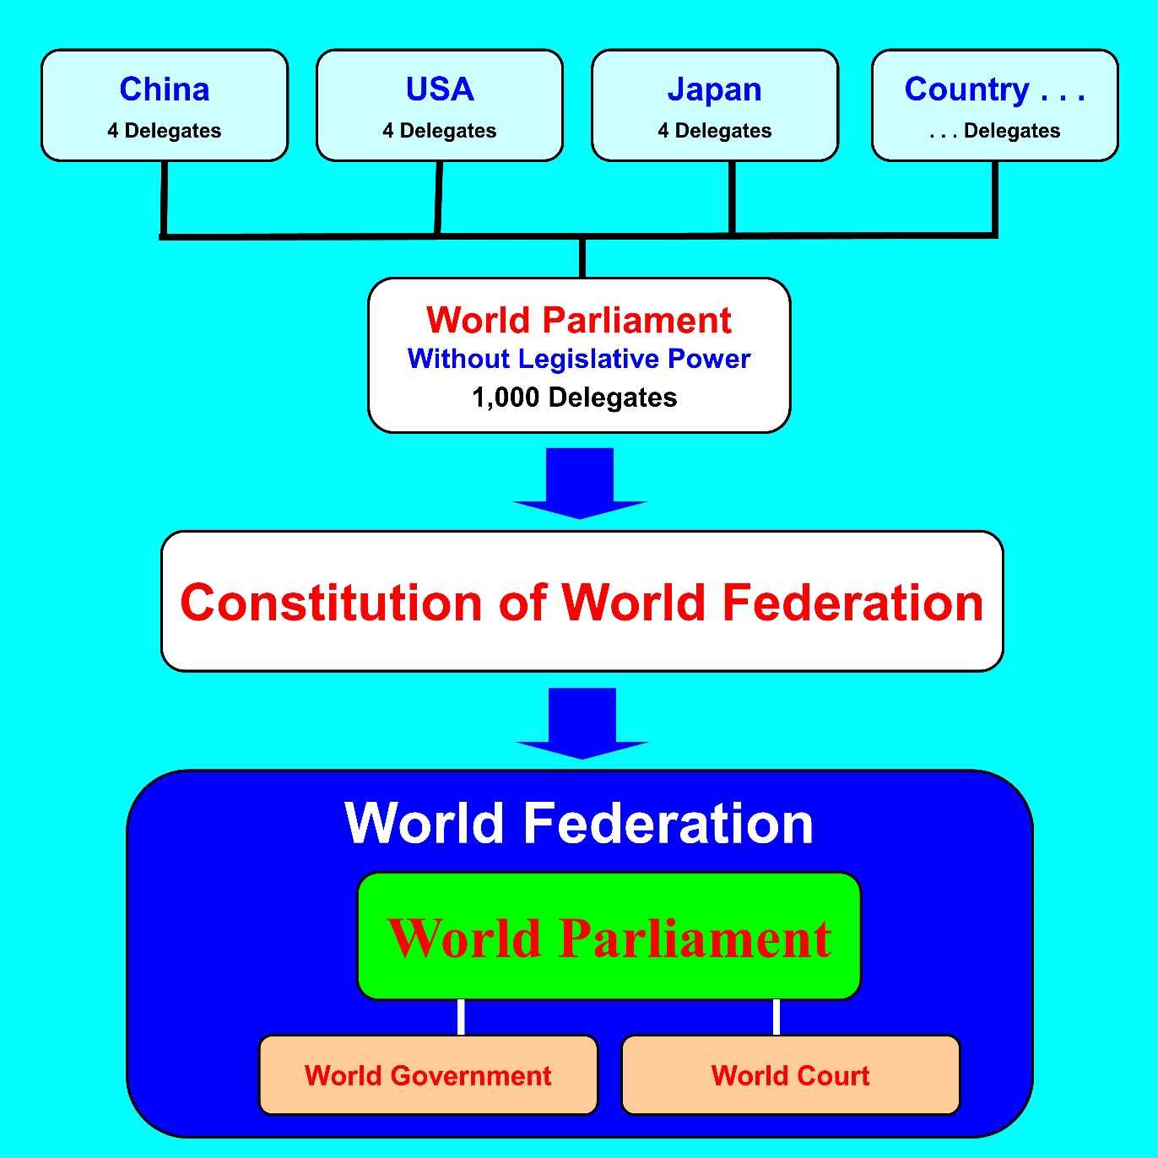

If the demand of removal reaches 10 percent of the total number of votes of delegates, the Board of Directors shall send, by the name of the President, a notice to each delegate. In the next step, if each delegates objects to the removal of the member, she or he shall send the document of objection to the President. If these objections reach more than half of the votes of delegates within 1 year from the notice by the President, the objected delegate is not removed. Otherwise, the delegate shall be removed even if the demand of removal is 10% of the votes of delegates. For example, as shown in the Figure VII-2, suppose the accepted delegates are 500 with 500 votes, and 50 delegates with 50 votes demand the removal of a delegate. In this case, within 1 year from the notice, if the delegates with 251 or more of votes object to the removal, she or he needs not be removed. If the delegates with 250 or less votes object to the removal, she or he shall be removed. This process can be implemented through the Internet. Namely, the process of removal can be implemented without holding the session of World Parliament.

Figure VII-2. Removal of Delegates
Votes of Delegates are 500

The delegates with 50 votes demand the removal of a delegate

If the objection to the removal is 251 or more votes, the delegate is not removed.
If the objection to the removal is 250 or less votes, the delegate is removed.

Even if there is no objection by document, delegates shall be removed when the World Parliament passed a resolution, by more than two thirds of votes of attending delegates, that the delegates shall be removed.
After delegates have been removed, the number of seats for delegates of each country shall be reduced according to the number of removed delegates for 4 years from the day of removal. For example, if 2 delegates are removed, the number of seats for delegates from the country shall be reduced by 2 for 4 years from the day of removal. The removed delegates may be accepted again after 4 years from the removal.
The Directors of the World Parliament, namely, the President, the Vice-President, the Secretary-General, the Secretaries, the Public Relations Officer, the Treasurer, and other Directors appointed by the President shall not be removed by the above procedure. The Directors shall be removed by impeachment.
If 490 delegates are removed from 500 delegate by this process, only 10 delegates may remain. But this remaining 10 delegates will become the supreme authority of World.

2. Finally

We have considered the maturity of soul. Basically, maturity of soul of all people must reach certain level before the truly democratic World Federation is established. If maturity of our soul reaches certain level, we can solve problems by dialogue in the World Federation. So, we must try to mature our soul. Education system must be improved. Above all, we must recognize the truly good things. At least we must think of the truly good things. The truly good thing shall become a common sense.
So, we must improve the maturity of our soul. We can improve the maturity of soul by making the World Federation the basic policy of each country.
Again, I would like to write about the cause of conflicts or wars the world. The essential cause of the conflicts is that the most powerful countries in the world do not love people. USA attacks other countries without the approval of United Nations, for example, invasion to Iraq. The most powerful country is like this. So, weak countries carry out selfish policy. For example, Colombia smuggles drug to USA. Fundamentally, this is because USA does not love people and treat people as livestock,
This is reflected in the atmosphere of society. In USA, there are many fantastic and stimulus things. But in the daily life, people are feeling lonely and empty. This is because leaders are treating people as livestock.

